Taiji Qi Gong & Meditation Retreat

* Friday 15th to Sunday 17th March 2024 *

A wonderful opportunity to rejuvenate ourselves, energetically and spiritually, through a weekend of Taiji & Qi Gong, Meditation and Bodywork. The venue Braziers provides the perfect environment, a tranquil Gothic Mansion set in 55 acres of meadows and woodland, nicely off the beaten track and with wonderful nourishing and wholesome vegetarian food..

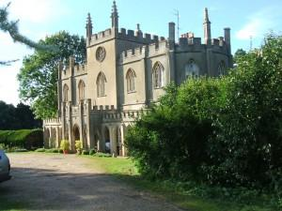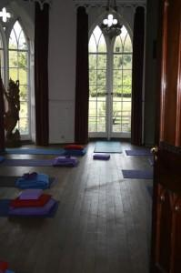

" The Retreat has done me the world of good”
" I enjoyed trying new things and both of you are excellent instructors, the whole event was very relaxing which is just what I needed”.

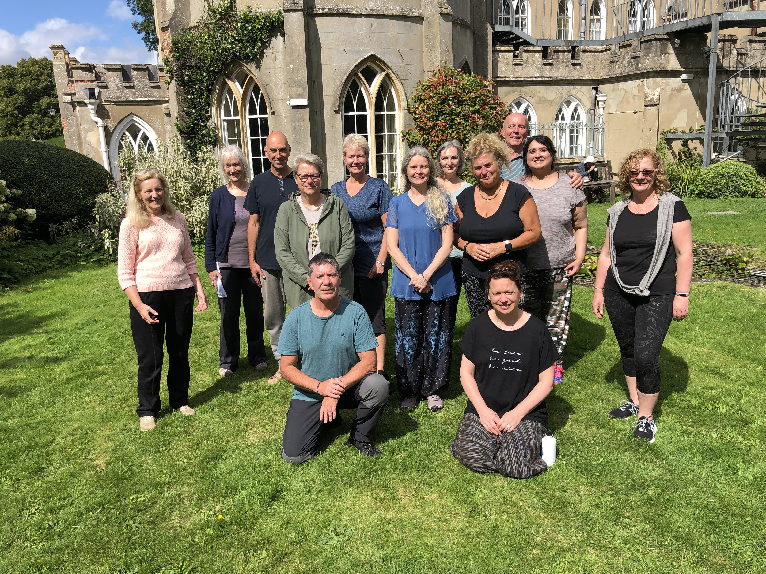

The weekend focuses more on easier to follow different Qigong forms and Tai Chi Foundation exercises. There will also be the chance to explore either Chen or Sun styles of Taiji, Tai Chi ruler and maybe some Wooden staff or sword exercises. The day starts with different sitting (on chairs) meditation exercises and usually a short walk through the woods. We will practice mostly inside in the Drawing room or the Barn but there hopefully will be opportunities also to practice in screened gardens, orchards and woodland.

Teachings are offered by Jeff Docherty & Mark Collins, practitioners of 20+ years.
Bookings: (www.cotswoldedgetaichi.co.uk)
- Reservations require a non-refundable deposit of £100.
- Fully incl. costs for two nights, full board & tuition from Fri 4pm - Sunday 4pm

- The Retreat with a Single Room is £395
- For a Shared Room with one other £355
Mark: 07981805206 cotswoldtaichi@gmail.com
Jeff: 07970 303694 jeffdocherty@yahoo.com

